File operation and permission

Objectives:
- File operation
- File permission
Filr Operation: To use the Linux terminal like a pro, we’ll need to know the basics of managing files and navigating directories.Differnet file operation is given below…

1. ls – List Files
The ls command lists the files in a directory. By default, ls lists files in the current directory.

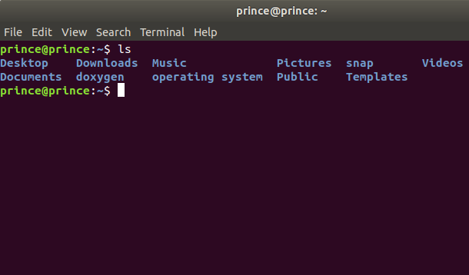

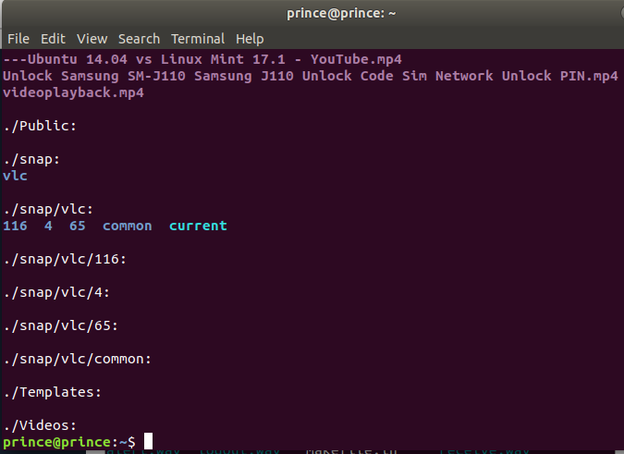
2. we can also list files recursively — that is, list all files in directories inside the current directory — with ls -R.

3. cd – Change Directory
The cd command changes to another directory. For example, cd Desktop will take you to your Desktop directory if you’re starting from your home directory.
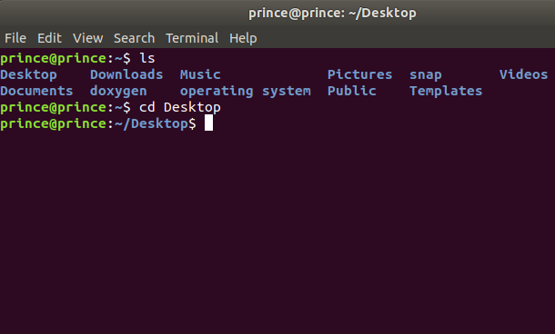

4. cd .. will take you up a directory.

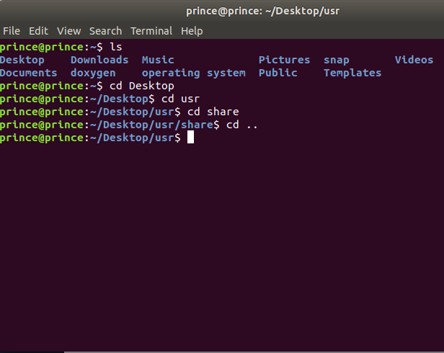

5.rmdir – Remove Directories
The rmdir command removes an empty directory. rmdir directory would delete the directory named “directory” in the current directory.

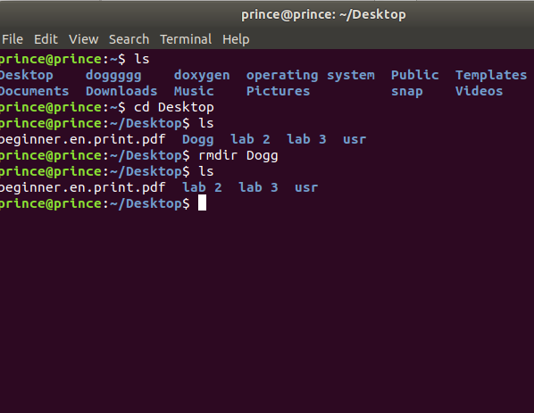

6) mkdir – Make Directories
The mkdir command makes a new directory. mkdir example will make a directory with the name “example” in the current directory.
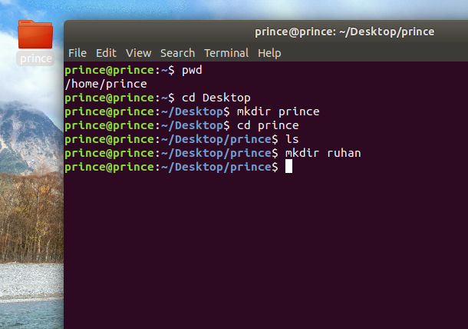

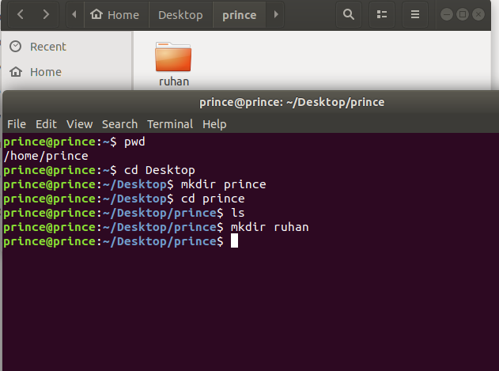

7) ln – Create Links
The ln command creates links. The most commonly used type of link is probably the symbolic link, which you can create with ln -s.
For example, the following command creates a link to our Downloads folder on our Desktop:
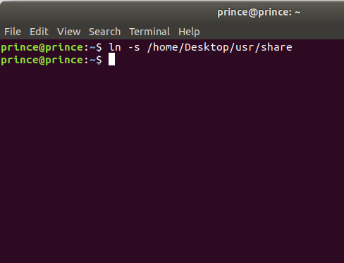

File Permissions:
There are 3 types of permissions:
1) Read
2) Write
3) Execute permission
Read (r): this gives permission to merely open a file or folder and view its contents.
Write (w): this gives permission to overwrite, append-to or delete a file or folder.
Execute (x): this gives permission to "run" a file. For example to run a script or a program.
So, how can we put this all into context? Let's have a look at the contents of a typical folder. I used the command ls -l to bring up this list:

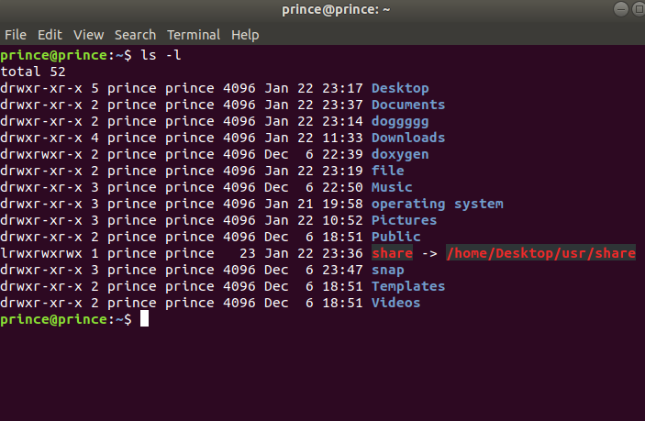

we can also do this via the command-line. Go to a directory that has files in it and type the following command to view all files in a list:
ls -al

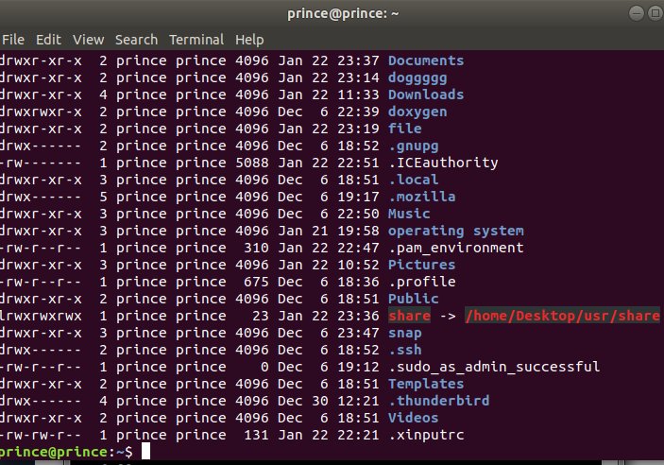
Next to each file and directory, we’ll see a special section that outlines the permissions it has. It looks like this:
-rwxrw-r–
The r stands for “read,” the w stands for “write,” and the x stands for “execute.” Directories will be start with a “d” instead of a “-“. You’ll also notice that there are 10 spaces which hold value. You can ignore the first, and then there are 3 sets of 3. The first set is for the owner, the second set is for the group, and the last set is for the world.

To change a file or directory’s permissions, let’s look at the basic form of the chmod command.
chmod [class][operator][permission] file
chmod [ugoa][+ or –] [rwx] file

u: This is for the owner.
g: This is for the group.
o: This is for all others.
a: This will change permissions for all of the above.
+: The plus sign will add the permissions which follow.
-: The minus sign will remove the permissions which follow.
r: Allows read access.
w: Allows write access.
x: Allows execution.

